Final Project Report

Warehouse Management System



Project Supervisor
Mr. Muhammad Kamran Qureshi

Submitted By

Software Projects & Research Section,
Department of Computer Sciences,
Virtual University of Pakistan


CERTIFICATE

This is to certify that () have worked on and completed their Software Project at Software & Research Projects Section, Department of Computer Sciences, Virtual University of Pakistan in partial fulfillment of the requirement for the degree of BS in Computer Sciences under my guidance and supervision.

In our opinion, it is satisfactory and up to the mark and therefore fulfills the requirements of BS in Computer Sciences.

Supervisor / Internal Examiner

Mr. Muhammad Kamran Qureshi
Supervisor,
Software Projects & Research Section,
Department of Computer Sciences
Virtual University of Pakistan

___________________
(Signature)

External Examiner/Subject Specialist
<<External Supervisor Name>>

___________________
(Signature)

Accepted By:

_____________
(For office use)

EXORDIUM

In the name of Allah, the Compassionate, the Merciful.

Praise be to Allah, Lord of Creation,
The Compassionate, the Merciful,
King of Judgment-day!

You alone we worship, and to You alone we pray for help,
Guide us to the straight path

The path of those who You have favored,

Not of those who have incurred Your wrath,
Nor of those who have gone astray.

DEDICATION

Dedicate to my parents and friends.

ACKNOWLEDGEMENT

I am thankful to Almighty “ALLAH” the most merciful compassionate and gracious.
PREFACE

This project report is written for Virtual University.
TABLE OF CONTENTS

CHAPTER NO. 1
gathering & Analyzing info 10

1.1 Introduction

1.2 purpose

1.3 scope

1.4 definitions, acronyms and abbreviations

1.5 Project requirements

1.5.1 Functional Requirements

1.5.2 Non-Functional Requirements

1.6 use cases and usage scenarios

1.6.1 Use Case Diagrams

1.6.2 Usage Scenarios

1.7 Development Methodology

1.7.1 Chosen Methodology

1.7.2 Reasons for Chosen Methodology
1.7.2 Work Plan (Gantt Chart)
1.7.2 Project Schedule (Submission Calendar)

CHAPTER NO. 2
designing the project 12

2.1 Introduction

2.2 purpose

2.3 scope

2.4 definitions, acronyms and abbreviations

2.5 Architectural Representation (Architecture Diagram)

2.6 Dynamic Model: Sequence Diagrams

2.7 Object Model/Logical Model: Class Diagram

2.8 Database Model (Database Diagram)

2.9 Graphical User Interfaces

Chapter no.3
DEvelopment 13
3.1 Development plan (Architecture Diagram)

CHAPTER 1
Gathering & Analyzing Info

1.1 Introduction

This software Requirements Specification aims to describe the Functionality, External Interfaces, Attributes and Design Constraints imposed on Implementation of the software system described throughout the rest of the document. Throughout the description of the software system, the language and terminology used should unambiguous and consistent throughout the document.

1.2 purpose

Defining and describing the functions and specifications of the Warehouse Management System is the primary goal of this Software Requirements Specification (SRS). This Software Requirements Specification illustrates, in clear terms, the system’s primary uses and required functionality.

1.3 scope

The Warehouse Management System for ABC Company encompasses the development of a comprehensive web-based application aimed at optimizing and automating the company's warehouse operations in Lahore, Karachi, Rawalpindi, Faisalabad, and Quetta. The system will include user authentication and authorization functionalities, allowing the admin to create, update, and delete user accounts with specific rights. Admins will be able to manage the chart of accounts, including parent accounts, control accounts, and ledger accounts. Users, based on assigned rights, can enter, update, and delete records, generate detailed reports on stock movements, create vouchers for incoming and outgoing products, and review ledger entries. The system will facilitate decision-making by providing insights through various reports, including inventory reports, stock aging, stock value reports, and stock movement reports. The project will be developed using HTML, CSS, JavaScript, PHP, and MySQL, delivering a fully functional system with user documentation, source code, and training materials.

1.4 definitions, acronyms and abbreviations

SRS | Software Requirements Specification

1.5 Project requirements

1.5.1 Functional Requirements

- Admin will log in to the system using their login ID and password.
- Admin can create users and give rights to other users.
- Admin can use the entire system to enter, update, and delete any record.
- Admin can manage a chart of accounts (parent accounts, control accounts, and ledger accounts).
- Admin can generate a detailed report to view item-wise, day-wise, week-wise, or month-wise details of items coming in and out of the stock, and brand-wise details of items coming in and out.
- Only Registered users will be able to login to the system.
- User can also enter, update, and delete if the admin grants them complete rights.
- User can enter data into the system, such as creating vouchers and reviewing ledgers.
- User can view a report of all items in the warehouse by city.
- User can generate different reports such as inventory reports, stock aging, stock value reports, and stock movement reports.

1.5.2 Non-Functional Requirements

Performance:
Application should perform all of its functions excellently and effectively without any inconvenience.

Usability:
Usability of this Application must be easy so that users can use it without any difficulty.

User Friendly Interface:
Application design should simple and user friendly so user can understand it and performs functions easily.

1.6 use cases and usage scenarios

1.6.1 Use Case Diagrams

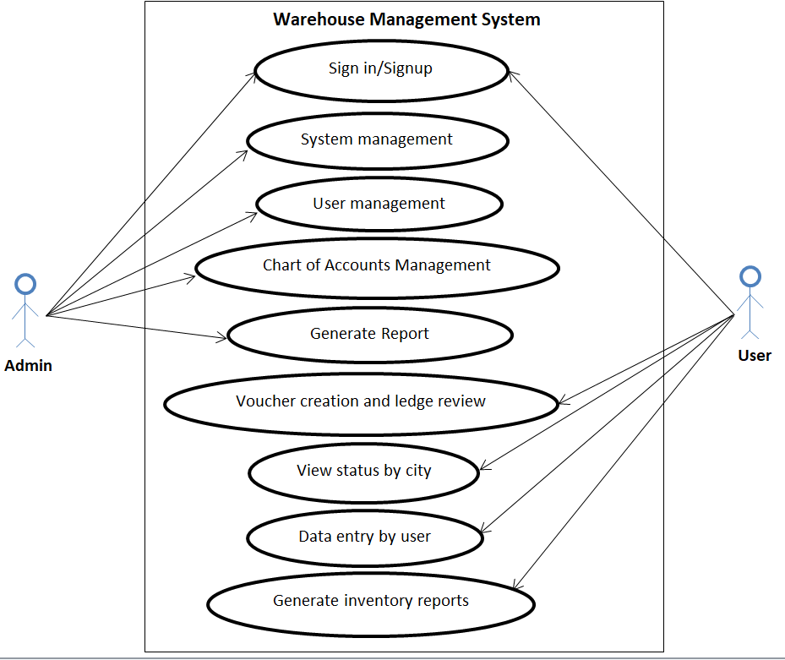

1.6.2 Usage Scenarios

Sign in/Signup
Use Case Title | Sign in/Signup
Use Case ID | 1
Actors | Admin
Action | Sign in/Signup for admin and User
Description | The admin logs into the system using a unique login ID and password.
Pre-Condition | Admin and User can Sign in/Sign Up to the System.
Post-Condition | If the Use Case is successful the user can easily access to the system.
Modification History | 1.0
Authority | Admin
Modification Date | 03-Dec-2023
Author

System Management
Use Case Title | System Management
Use Case ID | 2
Actors | Admin
Action | updating, and deleting any record
Description | The admin has access to the entire system for entering, updating, and deleting any record.
Pre-Condition | Admin can updating, and deleting any record
Post-Condition | If the Use Case is successful the user can easily access to the system.
Modification History | 1.0
Authority | Admin
Modification Date | 03-Dec-2023
Author

User Management
Use Case Title | User Management
Use Case ID | 3
Actors | Admin
Action | create new users, assign roles, and manage user rights
Description | The admin can create new users, assign roles, and manage user rights within the system.
Pre-Condition | Admin can create new users, assign roles, and manage user rights
Post-Condition | If the Use Case is successful the user can easily access to the system.
Modification History | 1.0
Authority | Admin
Modification Date | 03-Dec-2023
Author

Chart of Accounts Management
Use Case Title | Chart of Accounts Management
Use Case ID | 4
Actors | Admin
Action | manage the chart of accounts, including parent accounts, control accounts, and ledger accounts
Description | The admin can manage the chart of accounts, including parent accounts, control accounts, and ledger accounts.
Pre-Condition | Admin can manage the chart of accounts, including parent accounts, control accounts, and ledger accounts
Post-Condition | If the Use Case is successful the user can easily access to the system.
Modification History | 1.0
Authority | Admin
Modification Date | 04-Dec-2023
Author

Generate Reports
Use Case Title | Generate Reports
Use Case ID | 5
Actors | Admin
Action | Generate detailed reports based on item-wise, day-wise, week-wise, or month-wise stock details.
Description | The admin can generate detailed reports based on item-wise, day-wise, week-wise, or month-wise stock details, as well as brand-wise details of stock movements.
Pre-Condition | Admin can generate detailed reports based on item-wise, day-wise, week-wise, or month-wise stock details,
Post-Condition | If the Use Case is successful the user can easily access to the system.
Modification History | 1.0
Authority | Admin
Modification Date | 04-Dec-2023
Author

Data Entry by user
Use Case Title | Data Entry by User
Use Case ID | 6
Actors | Users
Action | enter, update, and delete data
Description | Users can enter, update, and delete data if granted permission by the admin.
Pre-Condition | User can enter, update, and delete data
Post-Condition | If the Use Case is successful the user can easily access to the system.
Modification History | 1.0
Authority | Users
Modification Date | 04-Dec-2023
Author

Voucher Creation and Ledge Review
Use Case Title | Voucher Creation and Ledge Review
Use Case ID | 7
Actors | Users
Action | create vouchers, and review ledgers
Description | Users can enter data into the system, create vouchers, and review ledgers with the appropriate permissions.
Pre-Condition | Users can create vouchers, and review ledgers
Post-Condition | If the Use Case is successful the user can easily access to the system.
Modification History | 1.0
Authority | Users
Modification Date | 05-Dec-2023
Author

View Status by City
Use Case Title | View Status by City
Use Case ID | 8
Actors | Users
Action | view the status
Description | Users can view the status of all items in the warehouse categorized by city.
Pre-Condition | Users can view the status of all items
Post-Condition | If the Use Case is successful the user can easily access to the system.
Modification History | 1.0
Authority | Users
Modification Date | 05-Dec-2023
Author

Generate Inventory Reports
Use Case Title | Generate Inventory Reports
Use Case ID | 9
Actors | Users
Action | generate various reports, including inventory reports; stock aging, stock value reports, and stock movement reports
Description | Users can generate various reports, including inventory reports; stock aging, stock value reports, and stock movement reports.
Pre-Condition | Users can generate various reports, including inventory reports; stock aging, stock value reports, and stock movement reports
Post-Condition | If the Use Case is successful the user can easily access to the system.
Modification History | 1.0
Authority | Users
Modification Date | 05-Dec-2023
Author

1.7 Development Methodology

1.7.1 Chosen Methodology

The methodology chosen for this project is VU Process Model. This process offers numerous advantages for software developers and because of its beneficial flow I use this methodology. This model is the combination of Waterfall and Spiral Model. This is a hybrid approach for system development, which maximizes the quality of system and minimizes the disadvantages and risks.

1.7.2 Reasons for Chosen Methodology
- Testing is inherited to every phase.
- With the help of this model monitoring of software development is easy.
- Its development cycle and every phase has defined start and end date.
- It is documentation driven which means documentation is produced at every stage.
- It is an enforced disciplined approach because to having stages.
- Emphasis on requirement and design before writing code ensure minimal wastage of time and efforts.
- Its processing is two way if find any error in any phase it loop back the development into back phase.

1.7.2 Work Plan (Gantt Chart)
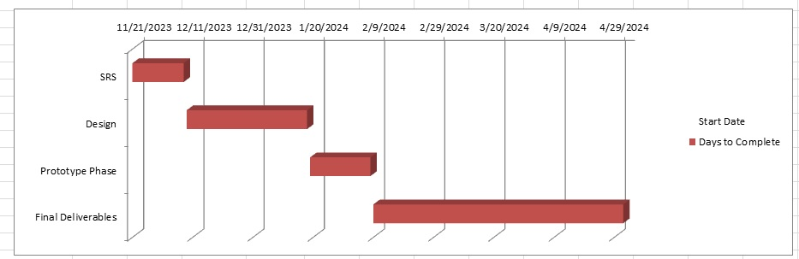
1.7.2 Project Schedule (Submission Calendar)

CHAPTER 2
Designing the Project

2.1 Introduction

This chapter is about the project design where the complete system working diagram draw. This will be the logical and conceptional view of the project work.

2.2 purpose

This document use for future application development and the reader for understand the concept of this application.

2.3 scope

This document use for future application development and the reader for understand the concept of this application. The diagram include in this document are ERD, Class diagram, Database diagram, Architecture diagram and sequence diagram. Interface design is use for the reader for understand the conceptual output and test case tables use for final application test.

2.4 definitions, acronyms and abbreviations

SDL | Software development lifecycle

2.5 Architectural Representation (Architecture Diagram)

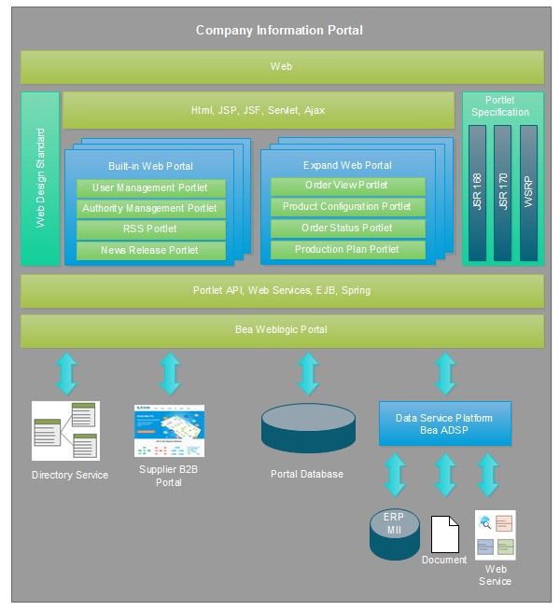

2.6 Dynamic Model: Sequence Diagrams

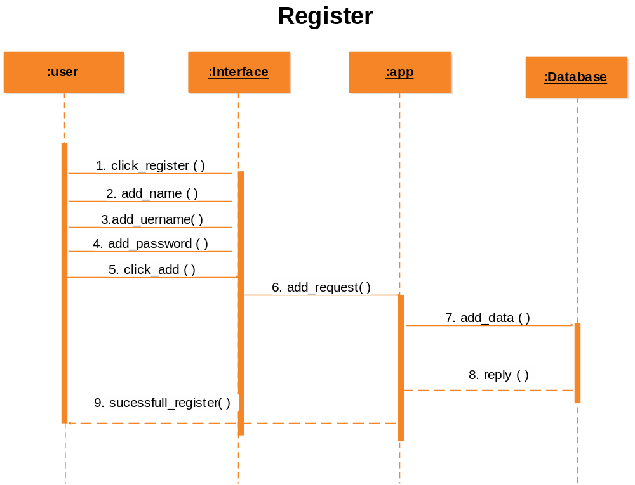

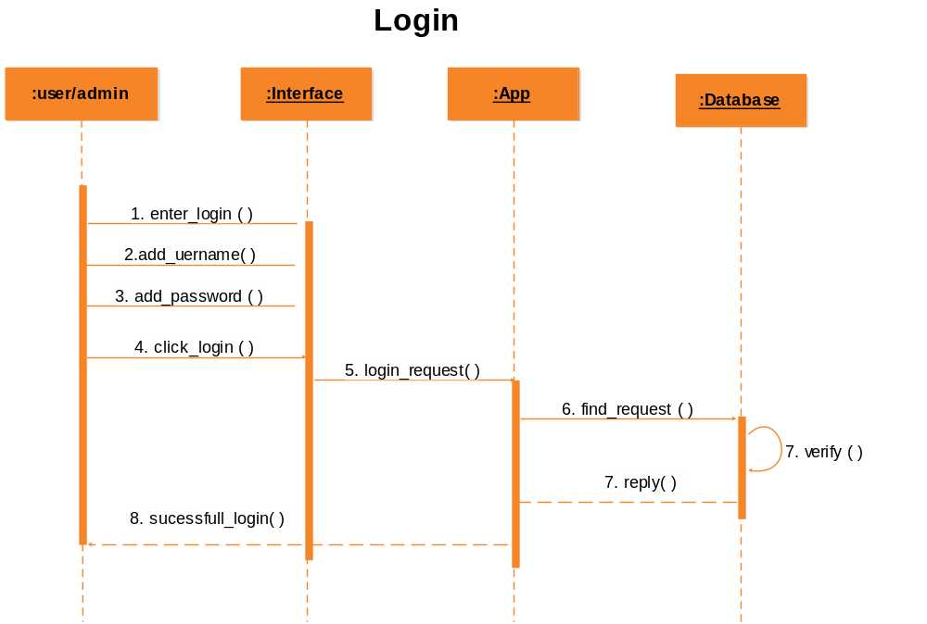

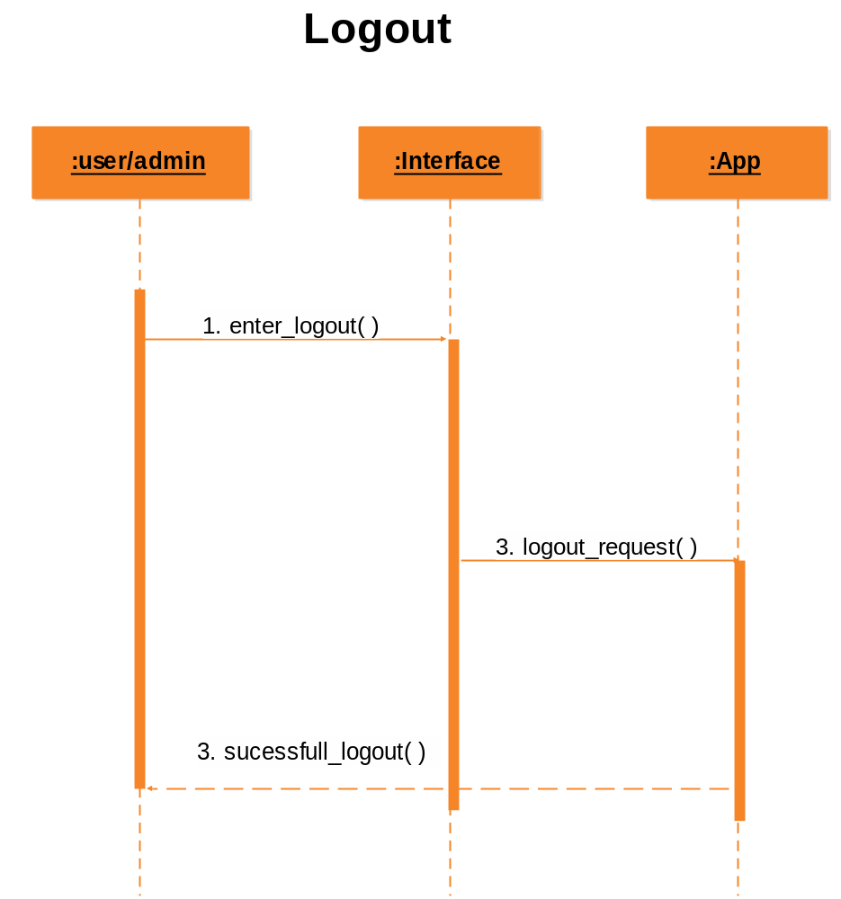

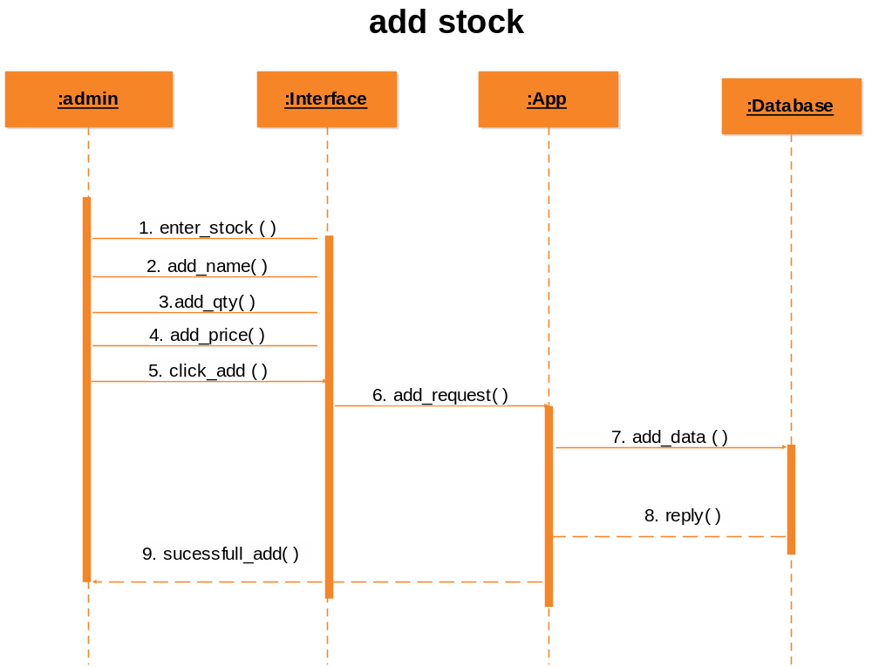

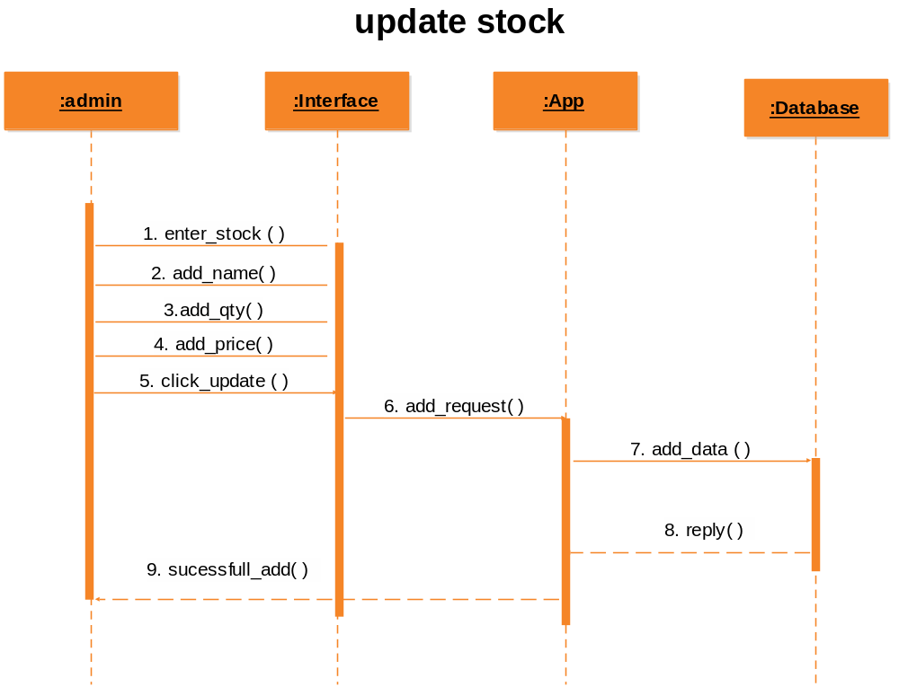

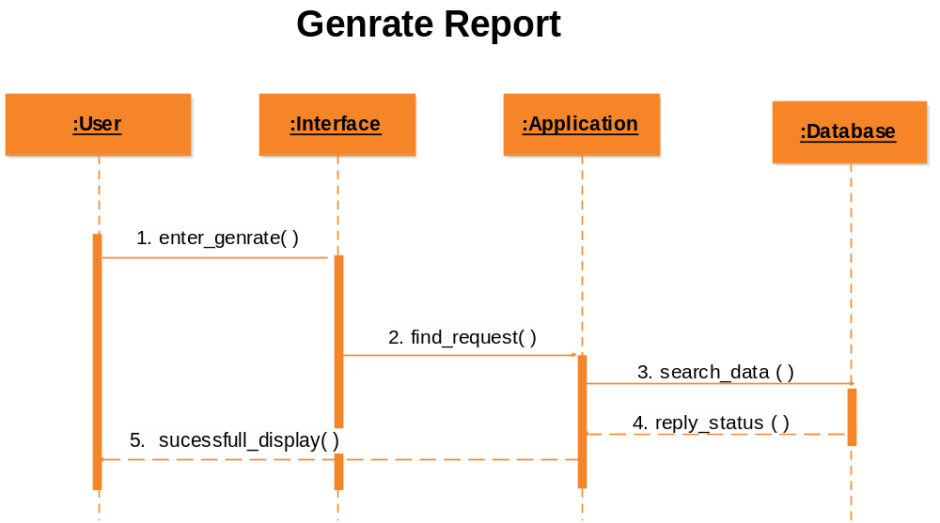

2.7 Object Model/Logical Model: Class Diagram

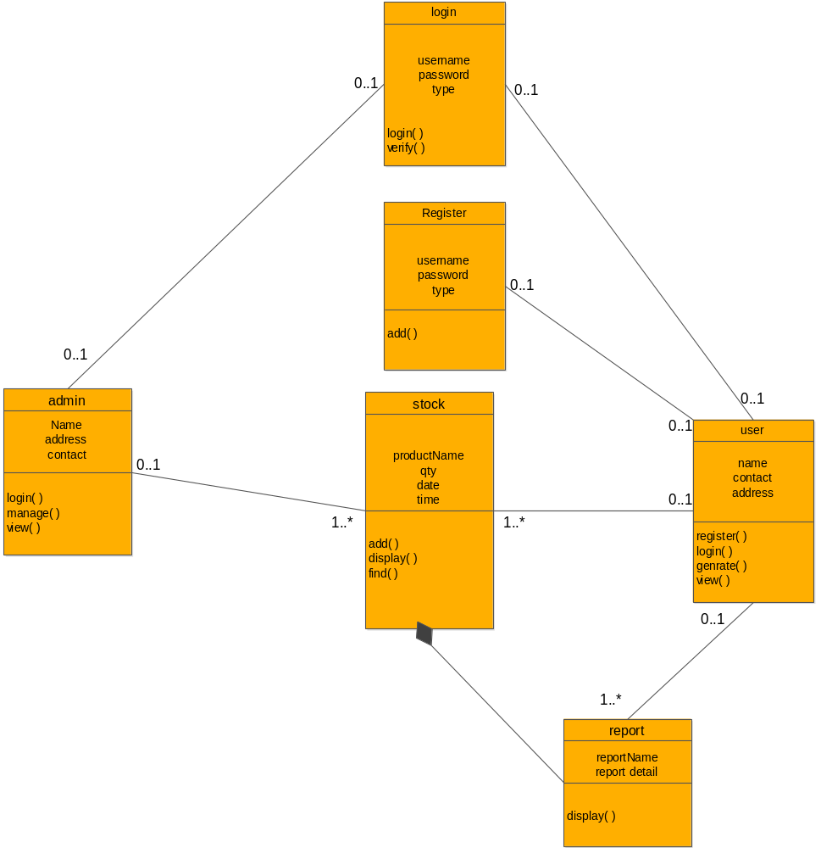

2.8 Database Model (Database Diagram)

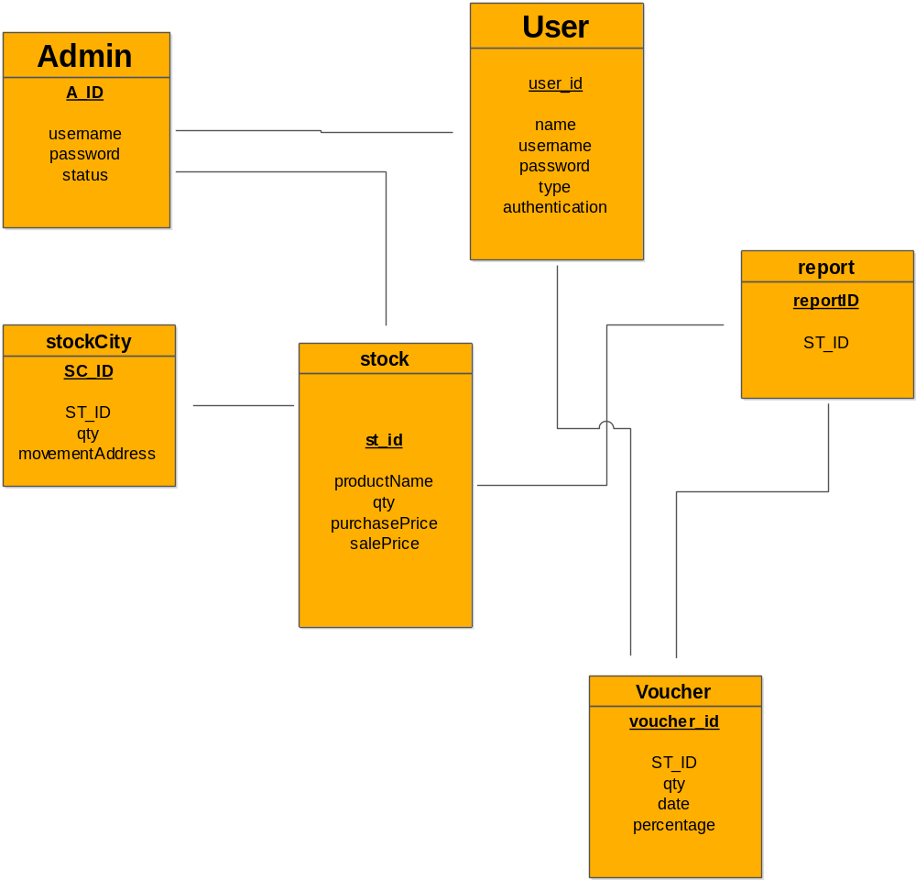

2.9 Graphical User Interfaces

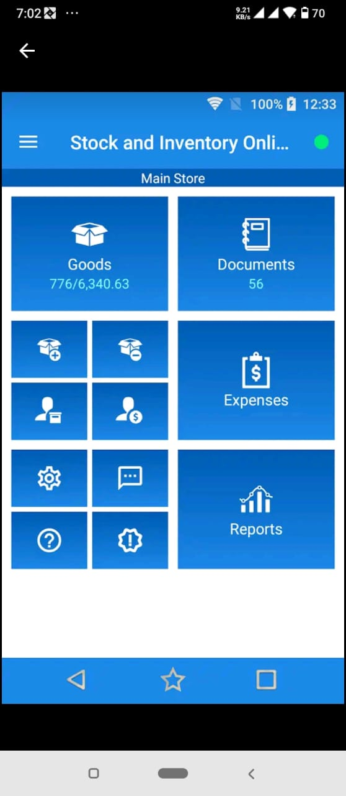

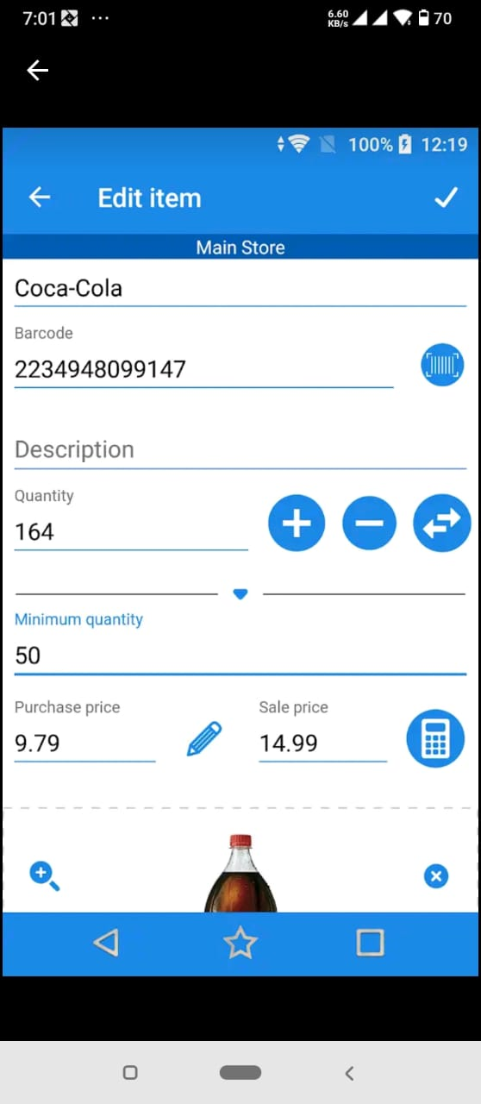

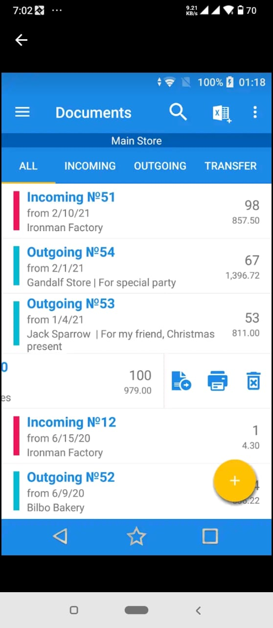

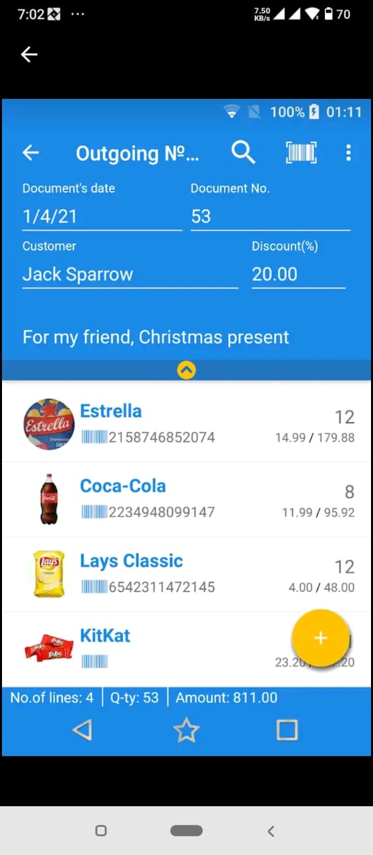

CHAPTER 3
Development

3.1 Development plan (Architecture Diagram)

REFERENCES

- https://www.php.net/

APPENDIX

